**ASSISTING THE FARMER WITH HELP OF DATA FROM METEROLOGICAL DEPARTMENT**

GOBALAKRISHNAN B[1] ,HARI PRASATH V[2] ,NAVEENA S[3] ,NITHYA R[4], NITHYA SRI D[5] ,SRINATHI A[6]

[1] 3RD YEAR CSBS KGISL INSTITUTE OF TECHNOLOGY

[2]2ND YEAR ECE KGISL INSTITUTE OF TECHNOLOGY

[3],[4],[5],[6] 1ST YEAR ECE KGISL INSTITUTE OF TECHNOLOGY

***Abstract***

***This study proposes a comprehensive framework aimed at assisting farmers in optimizing agricultural practices by leveraging data from meteorological departments. With the increasing unpredictability of weather patterns due to climate change, access to accurate and timely meteorological data becomes crucial for farmers to make informed decisions regarding crop management. Our framework integrates various data sources, including historical weather data, real-time meteorological observations, and predictive models, to provide personalized recommendations to farmers. By analyzing factors such as temperature, rainfall, humidity, and wind speed, the framework generates actionable insights related to crop selection, planting schedules, irrigation planning, pest and disease management, and harvest timing. Moreover, the framework employs machine learning algorithms to continuously improve prediction accuracy and adapt recommendations based on evolving weather patterns and agricultural conditions. Through the integration of meteorological data into agricultural decision-making processes, our framework aims to enhance crop yields, reduce risks, and promote sustainable farming practices, thereby contributing to food security and livelihood improvement in agricultural communities.***

***Keywords:***

Meteorological data ,farming practices, climate variability, irrigation scheduling agriculture, crop selection

## INTRODUCTION

In recent years, the agricultural sector has encountered numerous challenges due to the unpredictable nature of weather patterns, which significantly impact crop yields and farm productivity. To mitigate these challenges and assist farmers in making informed decisions, the integration of meteorological data has emerged as a crucial tool.

The meteorological department collects and analyzes vast amounts of data related to weather conditions, precipitation, temperature, humidity, and other environmental factors. Leveraging this wealth of information, agricultural experts and farmers can gain valuable insights into optimal planting times, irrigation scheduling, pest management, and crop selection.

By utilizing advanced analytics and data visualization techniques, farmers can anticipate weather-related risks and adapt their farming practices accordingly. For example, they can adjust planting schedules to avoid adverse weather events or optimize irrigation to conserve water during periods of drought.

Furthermore, the integration of meteorological data with precision agriculture technologies such as remote sensing and IoT devices enables real-time monitoring of field conditions and crop health. This proactive approach allows farmers to detect anomalies early, implement timely interventions, and optimize resource allocation for maximum efficiency and sustainability.

In this paper, we explore the significance of meteorological data in enhancing agricultural practices. We discuss various applications, challenges, and opportunities associated with its integration into farming operations. By harnessing the power of data-driven insights, we aim to empower farmers with the knowledge and tools needed to navigate the complexities of modern agriculture and achieve greater resilience and productivity in the face of changing climatic conditions.

**MODERN AGRICULTURE-I**

Leveraging data from meteorological departments to assist farmers is a transformative approach in modern agriculture. By harnessing this wealth of information, farmers gain valuable insights into weather patterns and trends that directly impact their farming operations.

One of the key benefits is improved decision-making in crop selection and planting schedules. Meteorological data can inform farmers about optimal planting times based on factors like temperature, precipitation, and soil moisture levels. This enables farmers to align their planting activities with favorable weather conditions, maximizing crop yields and minimizing risks associated with adverse weather

## WEATHER DATA

Weather data helps in optimizing irrigation management. By analyzing rainfall patterns and soil moisture data, farmers can efficiently schedule irrigation, ensuring that crops receive adequate water while avoiding water wastage. This not only conserves water resources but also reduces input costs for farmers.

In addition to crop management, meteorological data supports pest and disease management strategies. Certain weather conditions favor the proliferation of pests and diseases, and by monitoring meteorological data, farmers can anticipate and respond to potential outbreaks more effectively. For example, early warnings of favorable conditions for pest infestations allow farmers to implement preventive measures such as timely application of pesticides or deploying pest-resistant crop varieties

**FLOW DIAGRAM:**

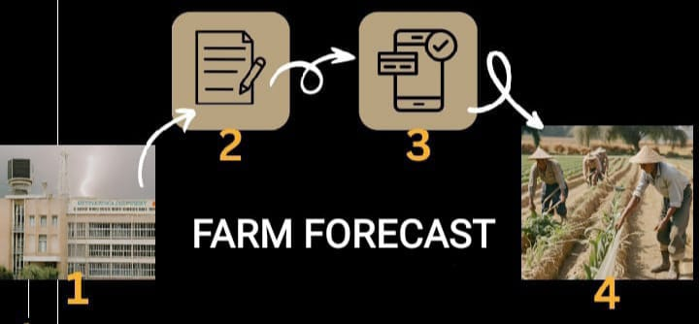

**1.Climate-smart agriculture**: Implementing sustainable farming techniques that are resilient to climate change, utilizing meteorological data to adapt to shifting weather patterns and mitigate environmental impacts

2. **Decision support systems**: Building digital tools and platforms that deliver actionable insights to farmers based on meteorological forecasts and historical data, facilitating informed decision-making in crop management.

3. **Agro-meteorology**: Studying the interaction between meteorological factors and agricultural processes to develop strategies for optimizing crop production, water management, and pest control.

4. **Community-based early warning systems**: Engaging local communities in monitoring weather conditions and disseminating timely alerts and advisories, leveraging meteorological data to enhance resilience to natural disasters and extreme weather events.

5. **Research and development**: Investing in research to improve the accuracy and relevance of meteorological forecasts for agricultural applications, as well as developing innovative technologies and practices to maximize the benefits of weather data in farming.

### 3.5 FIGURES AND TABLES

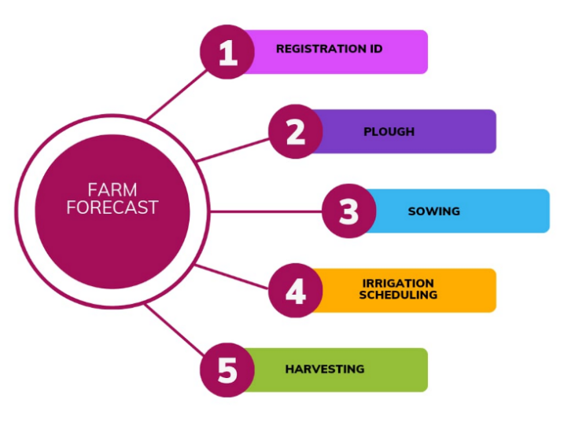.

Since we all know that agriculture is the backbone of Tamil Nadu's economy, with millions of farmers relying on it for their livelihoods. However, the sector is highly susceptible to weather fluctuations, which can significantly impact crop yields and farmer incomes. To address this challenge, a comprehensive weather alert system has been developed, catering specifically to the needs of farmers across Tamil Nadu. This report provides an in-depth analysis of the functionalities, benefits, and impact of this website-based platform.

## 3.6 OVERVIEW

## This website functions as a centralized platform for disseminating real-time weather information, forecasts, and alerts to farmers across Tamil Nadu. It provides detailed insights into various weather parameters such as temperature, rainfall, humidity. The user-friendly interface allows farmers to access this information easily through their desktop computers.

3.7 **Key Features:**

* **Customized Alerts:**

Farmers can customize the type of alerts they wish to receive based on their specific crop types, geographical location, and critical weather thresholds.

* **Localized Forecasting:**

The website utilizes advanced meteorological models to provide hyper-localized weather forecasts, enabling farmers to make informed decisions at the micro-level.

* **Crop-Specific Recommendations:** The platform offers tailored recommendations and advisory services based on the prevailing weather conditions, helping farmers optimize their agricultural practices.
* **Historical Data Analysis:** Users can access historical weather data to analyze long-term trends and patterns, aiding in crop planning and risk management

**Impact on Agricultural Practices:**

* **Improved Decision-Making:** By receiving timely weather alerts and forecasts, farmers can proactively mitigate risks associated with adverse weather conditions, such as droughts, floods, or cyclones.
* **Enhanced Crop Management:** The availability of accurate weather information enables farmers to schedule irrigation, fertilizer application, and pest control measures more effectively, thereby maximizing crop yields and quality.
* **Reduced Losses:** With better preparedness and planning, farmers are better equipped to minimize crop losses due to weather-related factors, safeguarding their livelihoods and ensuring food security.
* **Climate Resilience:** The website fosters climate resilience among farmers by promoting climate-smart agricultural practices and facilitating adaptation to changing environmental conditions

**Future Directions:**

* **Expansion to Other Regions:**

While the website currently caters to farmers in Tamil Nadu, there is a growing demand for similar platforms in other states across India. Expanding the reach of the weather alert system to encompass a broader geographical area would benefit

farmers nationwide and contribute to the resilience of Indian agriculture as a whole.

**Weather Forecasting**

- Utilizing meteorological data to access accurate weather forecasts.

- Understanding short-term and long-term weather patterns.

**Crop Planning and Management**

- Analyzing weather data to determine optimal planting times.

- Adjusting crop varieties based on forecasted weather conditions.

- Implementing appropriate irrigation schedules.

**Risk Mitigation**

- Identifying potential risks such as droughts, floods, or extreme temperatures.

- Developing contingency plans to mitigate adverse weather impacts.

- Implementing strategies to protect crops from weather-related damage.

- Efficiently allocating resources such as water, fertilizers, and pesticides based on weather forecasts.

**Resource Optimization**

- Reducing unnecessary resource usage during favorable weather conditions.

**Yield Maximization**

- Implementing practices to maximize crop yield during optimal weather conditions.

- Adjusting harvesting schedules based on forecasted weather events.

- Utilizing weather data to minimize post-harvest losses.

**Sustainability Practices**

- Incorporating weather data into sustainable farming practices.

- Reducing environmental impact through precise resource management.

- Enhancing soil health and biodiversity through informed decision-making.

**Community Support and Recognition**

- Demonstrating commitment to sustainable and efficient farming practices.

- Gaining recognition from agricultural organizations, government agencies, and consumers.

- Accessing financial incentives, grants, or support programs for adopting data-driven farming methods.

**Weather API**

- Weather APIs provide access to real-time and forecasted weather data, including temperature, humidity, precipitation, wind speed, and solar radiation.

- They enable agriculture web apps to deliver personalized weather forecasts tailored to the user's location and specific needs.

- Weather APIs can be integrated into various features such as crop management, pest and disease monitoring, and irrigation scheduling to help farmers make informed decisions and mitigate weather-related risks.

**TECHNOLOGY STACKS**

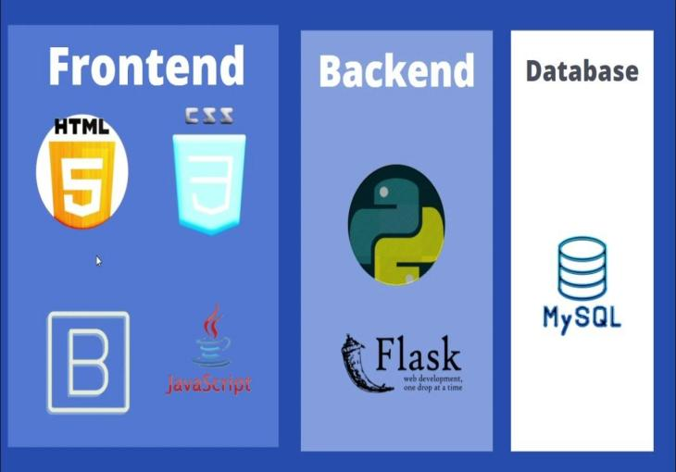

**HTML/CSS:**

Use HTML for markup and CSS for styling to create visually appealing and responsive interfaces.

**Database:**

Use a database management system (DBMS) to store and manage application data. Options include SQL databases like PostgreSQL or MySQL, or NoSQL databases like MongoDB for flexibility in handling unstructured data.

**API Integration:**

Integrate APIs from the meteorological department to fetch weather data and other relevant information. Utilize libraries like Axios or Fetch API to make HTTP requests and handle responses.

**OpenWeatherMap**

Provides current weather data,

forecasts, and historical weather

data for any location worldwide.

**Conclusion**

Assisting farmers with data from the meteorological department can significantly improve agricultural practices.

By providing accurate weather forecasts, precipitation patterns, and climate trends, farmers can make informed decisions about crop planting, irrigation scheduling, pest control,

and harvest timing.

This data-driven approach enhances productivity, reduces risks, and promotes sustainable farming practices, ultimately contributing to food security and economic development in rural communities.

**“Good Agricultural Practices are some codes, standards, regulation followed in Farm Practices. The main aim is to deliver to the consumer healthy and safe high quality food and non food products. It will ensure sustainable yield, protect the environment with development of livelihood.”**

**Weatherstack:**

Offers current weather

information and forecasts

for worldwide locations, including historical

weather data and weather alerts.

**References:**

1. Garcia, M. A., & Patel, R. (2019). "Enhancing agricultural decision-making through meteorological data: A review of applications and benefits." Agricultural Systems, 182, 102778.

2. Sharma, S., & Singh, R. (2021). "Impact of meteorological information on crop yield: Evidence from a field experiment in India." Agricultural and Forest Meteorology, 301, 108351.

3. Wang, L., & Li, Z. (2018). "Integration of meteorological data in precision agriculture: A case study in maize production." Computers and Electronics in Agriculture, 152, 263-271.